2025
YOUR LOGO
BusINESS PLAN 2025

[Your Golf Enterprise Name]
[Company name] | [Company address]
Table of Contents
HOW TO USE THIS TEMPLATE 2
1. EXECUTIVE SUMMARY 2
Market Opportunity 2
Products/Services Offered 2
Marketing & Sales Strategies 3
Financial Highlights 3
2. COMPANY OVERVIEW 3
Ownership Structure 3
Mission Statement 3
Business History 4
Future Goals 4
3. MARKET ANALYSIS 4
Target Market 4
Market Size 4
Competitive Analysis 5
Market Trends 5
4. PRODUCTS AND SERVICES 5
Core Services 5
Additional Services 6
5. SALES AND MARKETING STRATEGIES 6
Unique Value Proposition 6
Pricing Strategy 6
Marketing Channels 7
6. OPERATIONS PLAN 7
Staffing & Training 8
Equipment & Facilities 8
Operational Processes 8
7. MANAGEMENT TEAM 8
Key Managers 8
Advisory Board 9
8. FINANCIAL PLAN 9
Revenue Model 9
Cost Structure 9
Financial Projections 10
Break-even Analysis 10
9. APPENDIX 10
CHECKLIST 11
NOTES 11

HOW TO USE THIS TEMPLATE
This template is a comprehensive guide to help you create a professional business plan for your golf enterprise. Each section includes detailed explanations and examples.

🔍 Text in gray boxes provides guiding explanations
📝 Italic text indicates areas you need to fill in
💡 Sections marked "Example:" are for reference

1. EXECUTIVE SUMMARY

> 🔍 This section summarizes the key points of your business plan. It's critical for readers who won't read the entire plan. Recommended to write this last.

Market Opportunity
_Explain the market opportunity and why you're entering this business now._

Example:
"Golf tourism in our region has shown 25% growth over the past 5 years, with a clear gap for professional golf facilities. There is a demand for a modern golf facility offering premium services for both increasing tourist numbers and local golf enthusiasts."

Products/Services Offered
_Briefly list your main products and services._

Example:
- 18-hole championship golf course
- Golf academy and training programs
- Pro shop and equipment rental
- Restaurant and social facilities

Marketing & Sales Strategies
_Summarize how you'll acquire customers and grow._

Financial Highlights
_Share key financial projections._

Example:
- Year 1 Revenue Target: $10M
- Estimated Profit Margin: 25%
- Break-even Point: Month 18
- Initial Investment: $25M

-------------------

2. COMPANY OVERVIEW

> 🔍 Explain the fundamentals of your business in this section.

Ownership Structure
_State the legal structure and owners of the company._

Mission Statement
_Explain your company's purpose._

Example:
"Our mission is to advance the sport of golf in [Region] and deliver a world-class golf experience through the latest technology and sustainable practices."

Business History
_Company founding story and major milestones_

Future Goals
_Define short, medium, and long-term goals._

-------------------

3. MARKET ANALYSIS

> 🔍 Analyze your market in detail.

Target Market
_Define your customer segments._

Example Customer Persona:
1. Corporate Executive John
- Age: 45
- Income: $150,000+/year
- Interest: Golf enthusiast
- Need: Premium golf experience

Market Size
Share TAM (Total Available Market), SAM (Serviceable Available Market), and SOM (Serviceable Obtainable Market) data.

Competitive Analysis

Example Competitor Analysis Table:
Competitor | Strengths | Weaknesses
A Golf Club | - Established brand <br> - Large member network | - Aging infrastructure <br> - High prices
B Golf Course | - Modern facilities <br> - Good location | - Inexperienced team <br> - Limited services

Market Trends
_List important industry trends._

-------------------

4. PRODUCTS AND SERVICES

> 🔍 Detail all products and services you offer.

Core Services
_For each service, include:_
- Detailed description
- Pricing
- Features
- Competitive advantage

Example Service Card:
```
Premium Membership Package
───────────────────
✓ Unlimited course access
✓ Private golf lessons (2 hours/month)
✓ VIP parking
✓ Locker room access
✓ Tournament priority

Price: $50,000/year
```

Additional Services
_Complementary services to your core offerings_

-------------------

5. SALES AND MARKETING STRATEGIES

> 🔍 Explain how you'll reach and sell to customers.

Unique Value Proposition
_Highlight what sets you apart from competitors._

Pricing Strategy
_Explain your pricing model and rationale._
Membership | Price | Features

Marketing Channels
_List your marketing channels._

Example Channel Strategies:
1. Digital Marketing
- SEO-optimized website
- Social media campaigns
- Email marketing

2. Traditional Marketing
- Golf magazines
- Local events
- Referral program

-------------------

6. OPERATIONS PLAN

> 🔍 Detail how your business will operate.

Staffing & Training
_Organizational structure and staffing needs_

Example Staff Table:
Position | Numbers | Qualifications

Equipment & Facilities
_List of required equipment and facilities_

Operational Processes
_Flowcharts of key business processes_

-------------------

7. MANAGEMENT TEAM

> 🔍 Introduce your management team and advisors.

Key Managers
_For each manager, include:_
- Photo
- Biography
- Responsibilities
- Achievements

Advisory Board
_Profiles of your advisors_

-------------------

8. FINANCIAL PLAN

> 🔍 Share detailed financial projections.

Revenue Model
_Explain your revenue sources and projections._

Cost Structure
_List your fixed and variable costs._

Example Cost Table:

Cost Item | Monthly ($) | Annual ($)
Personnel | 250,000 | 3,000,000
Course Maintenance | 100,000 | 1,200,000
Utilities | 50,000 | 600,000

Financial Projections
_5-year projections:_
- Income Statement
- Cash Flow
- Balance Sheet

Break-even Analysis
_Calculate and explain your break-even point._
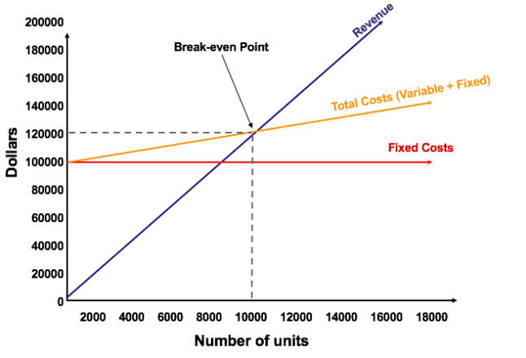

-------------------

9. APPENDIX

> 🔍 Include supporting documents.

- Market research reports
- Course plans
- Detailed financial tables
- Resumes
- Permits and licenses

-------------------

CHECKLIST

✓ All sections completed?
✓ Financial projections realistic?
✓ Market research current?
✓ Competition analysis detailed?
✓ Risks evaluated?
✓ Spelling and grammar checked?

-------------------

NOTES

- This template is customizable
- All financial data in USD
- Annual updates recommended
- Professional design recommended

-------------------

© 2025 Teelogix. All rights reserved.

